**Name:Shreyash Panage**

**Roll no:58**

Practical 02

Problem Definition: Create the following table structure and insert the data into it.

# Table deposit (Make account number as primary key, amount should not be less than 5000)

Name Null? Type

------------------------------------------ -------- ------------------------------------ ACTNO VARCHAR2(5)

CNAME VARCHAR2(10) BNAME

VARCHAR2(18)

AMOUNT NUMBER(8,2)

ADATE DATE

**Soln:**

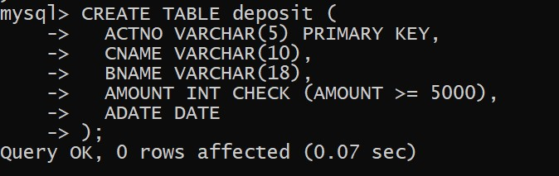

# Branch (bname should not be empty)

Name Null? Type

------------------------------------------- --------- ------------------------------------ BNAME VARCHAR2(18)

CITY VARCHAR2(18)

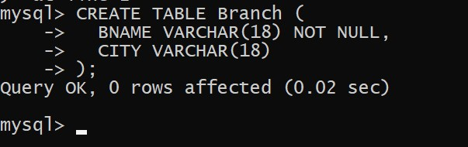

# Table Borrow

Name Null? Type

-------------------------------------------- --------- -----------------------------------------

LOANNO VARCHAR2(5)

CNAME VARCHAR2(18)

BNAME VARCHAR2(18)

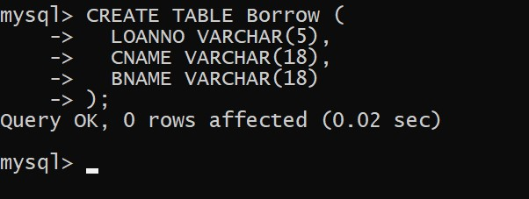

# Table Customer

Name Null? Type

-------------------------------------------- --------- ------------------------------------------ CNAME VARCHAR2(19)

CADDRESS VARCHAR(10)

CITY VARCHAR2(18)

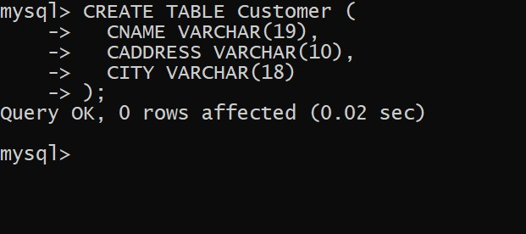

Answer the following queries:

1. Describe the structure of all the tables

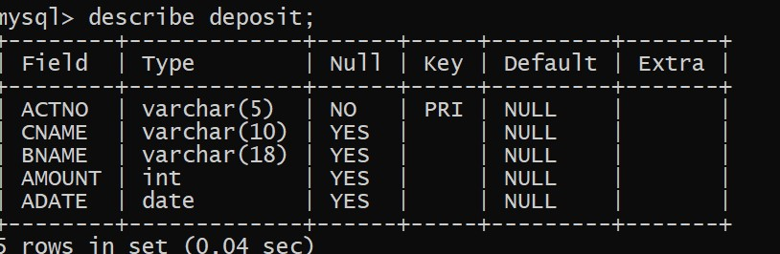

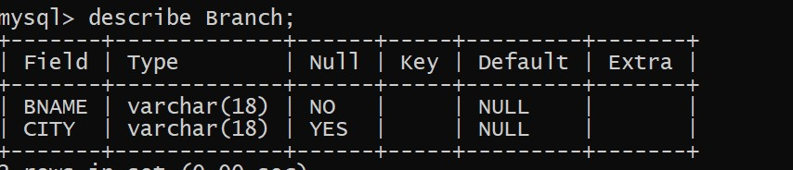

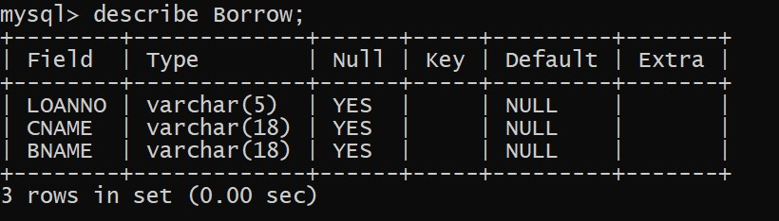

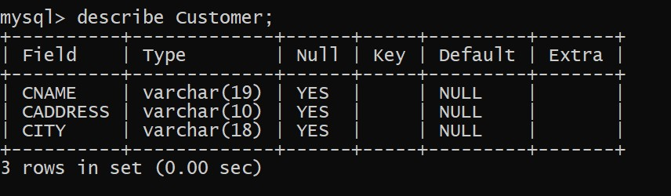

1. Change the coloumn size of cname of deposit table

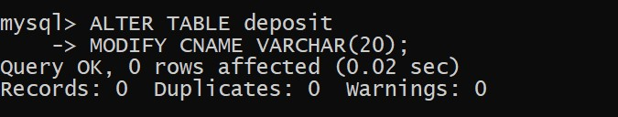

1. Remove the column caddress from customer

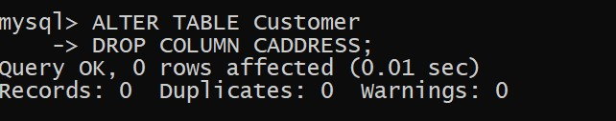

1. Change the name of cname as cust_name in deposit table.

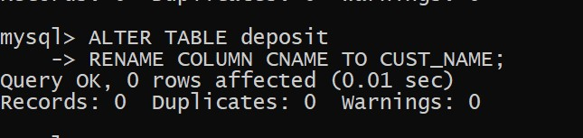

1. Display all the data stored in deposit

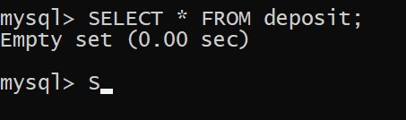

1. Display all the data stored in branch



1. Display all the data stored in borrow

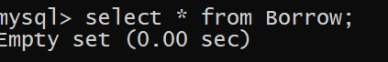

1. Display all the data stored in customer

